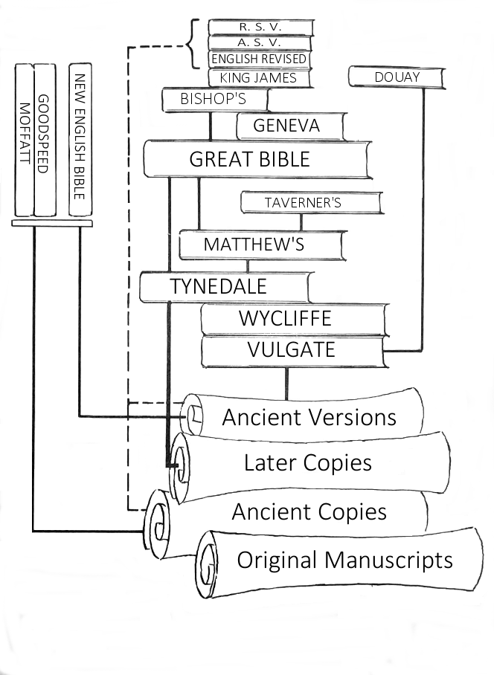
Original Manuscripts
- Tables of stone (Exodus 31:18, 34:1,28; Deuteronomy 27:2-3; cf. Joshua 8:30-32)
- Clay (primary writing materials in Assyria and Babylon) cf. Ezekiel 4:1
- Wood (Greece, Egypt, Palestine) cf. Isaiah 30:8; Habakkuk 2:2
- Leather (cf. Jeremiah 36:23, scribe’s knife used for the purpose of erasures) Though not specifically mentioned in scripture, this was probably the primary way the Old Testament was copied and preserved. (cf. 2 Timothy 4:13).
- Papyrus (Most important and common writing material in New Testament times. Popular throughout the world by fourth century B.C.)
  - Rolls, typically 30 feet long and 9 to 10 inches wide.
- Vellum or Parchment. Treated animal skins, creating an improvement over mere leather. (2nd century B.C.)
- Paper (Used by Chinese, 2nd century B.C.; but not by rest of the world until much later, 8th century)
- NOTE: We do not have any of the original manuscripts.
Early English Translations
- Christian religion came to Britain around 4th century, but the scriptures were only available in the Latin (Vulgate).
- It was in England where the battle was fought and won for the right of the common man to have the Bible translated into his language!
- From 8th – 11th centuries there were portions of the scriptures translated into Anglo-Saxon and Old English. Old English translations that survive include the Pentateuch, some historical books of the O.T., the Psalms and the Gospels.
- In the 13th and 14th centuries (in what is known as Middle English) parts of the Bible, most notable Psalms was put into English.
Wycliffe & Tyndale
- John Wycliffe (1330-1384) During Papal oppression, believed God’s word should be available to the common man. Finished entire translation from Latin to English in 1382. (First complete translation).
- William Tyndale – true father of English Version. Gave people translation from original Greek and Hebrew. To his opponents he once said, “If God spare my life, ere many years I will cause a boy that driveth the plow shall know more of the Scripture than thou doest.” Translated New Testament by 1526, despite condemnation of Catholics. Portions of the Old Testament and New Testament revisions finished by 1535. He was burned at the stake by Romanists in 1536.
Other Bibles:
- Matthew’s Bible, translated by John Rogers (1537). Taverner’s, a revision of Matthew’s Bible (1539). Great Bible, revision of Matthew’s Bible, first authorized to be read in the churches (1539). Note: Some preachers complained because people chose to read the Bible rather than listen to their sermons. Geneva Bible (1560) first small enough to be a personal Bible. Bishop’s Bible, English Church’s response to the Geneva Bible (1568). It was a revision of the Great Bible. Douay Bible, first Catholic Bible (1610), translated from Latin.
- King James Bible: King James decreed that there would be no comments, except what was essential in translating the text. Revision of the Bishop’s Bible, finished in 1611. (Approx. 48 scholars). In four centuries, many revisions as language changed. Generally adopted because: 1) Improvements in Gk. & Hb. Scholarship; 2) Maturity of English language led to a beautiful, poetic translation. 3) Lack of comments allowed all parties to accept it. (Approximately 90% of Tyndale’s translation is preserved today in the KJV).
- ERV, ASV, RSV: Note: KJV rests upon an inadequate textual base. Older and substantial copies of the New Testament (Vatican, Sinaitic, Alexandrian, Ephraem manuscripts) were discovered after it was completed. English Revised Version was commissioned by Church of England, and finished in 1881. Because of differences between British and American scholars, a compromise was reached, leading to the ASV translation being published in 1901. RSV came about in 1952 to answer perceived shortcoming of the English and American translations.
- Modern Translations: NKJV, NIV, NASB, ESV. All of these are fairly good, but the NIV follows the example of the New English Bible with a “sense-for-sense” translation rather than a “word-for-word” translation. (Also known as dynamic equivalency). The advantages to the newer translations: 1) the opportunity of the translators to take advantage of the latest scholarship; 2) As the English language changes, older translations are harder to understand. All of the major translations (save possibly NIV) are dependable and can be profitably used by the English speaking believer.

